Q2. Shell

* Created a directory called shell

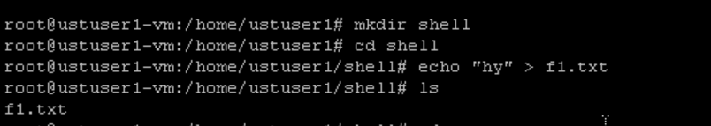

* This directory im going to make it as a tar file using shell scripting and also including the backup:

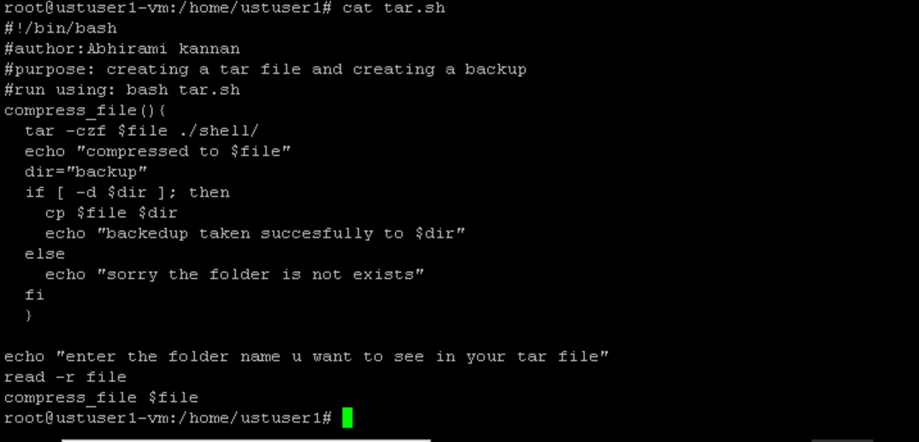

* Output:

